**VISUALIZATION TOOL FOR ELECTRIC VEHICLE CHARGE AND RANGE ANALYSIS**

**SRI SARADA NIKETAN COLLEGE OF SCIENCE FOR**

**WOMEN, KARUR**

**FACULTY MENTOR : Ms. E. NIRAIMATHI M.Sc., B.Ed.,**

**Project done by**

**P. KANIMOZHI - Team Leader**

**P. DEEPIKA - Team Member**

**V. SARUMATHI - Team Member**

**M. SOUNDHARYA -Team Member**

**S. YAZHINI -Team Member**

**Project Report Template**

1. **INTRODUCTION**

Visualization Tools for Electric Vehicle Charge and Range Analysis

* 1. **Overview :**

A Vehicle that can be powered by an electric motor that draws electricity from a battery and is capable of being charged from an external source and have an electric motor instead of an internal combustion engine.

The Electric Vehicle (EV) is not new, but it has been receiving significantly more attention in recent years . Advances in both EV analytics and battery technologies have led to increased automotive market share. The modern mechatronic vehicle marries electrical storage and propulsion systems with electric sensors, controls, and actuators, integrated closely with software, secure data transfer and data analysis. to form a comprehensive transportation solution

* 1. **Purpose :**

The purpose of this project is, peoples are aware about the EV Charge and Range Analysis.

1. **Problem Definition & Design Thinking**

**2.1 Empathy Map**

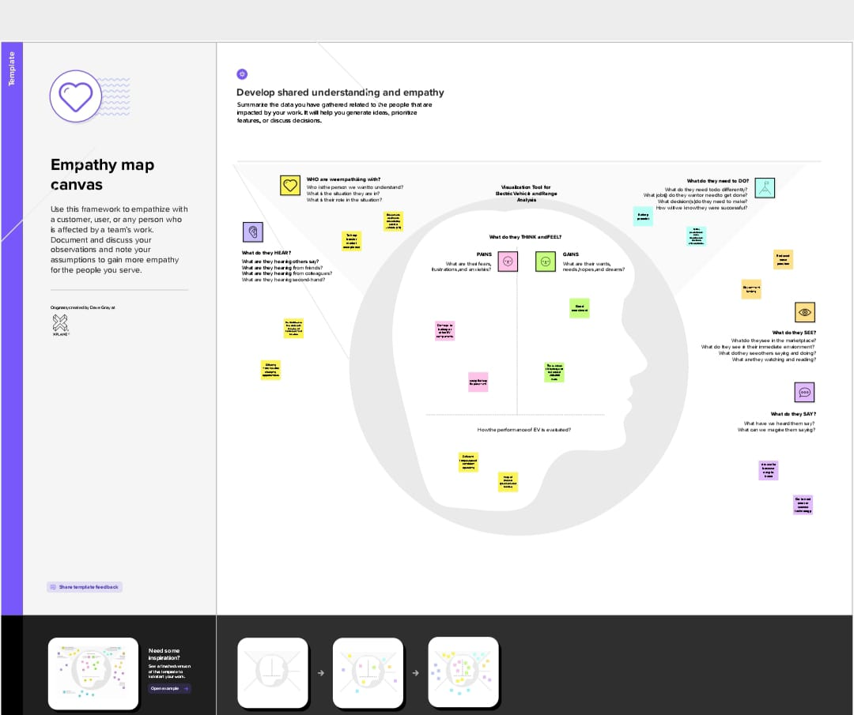

**2.2 Ideation & Brainstorming Map**

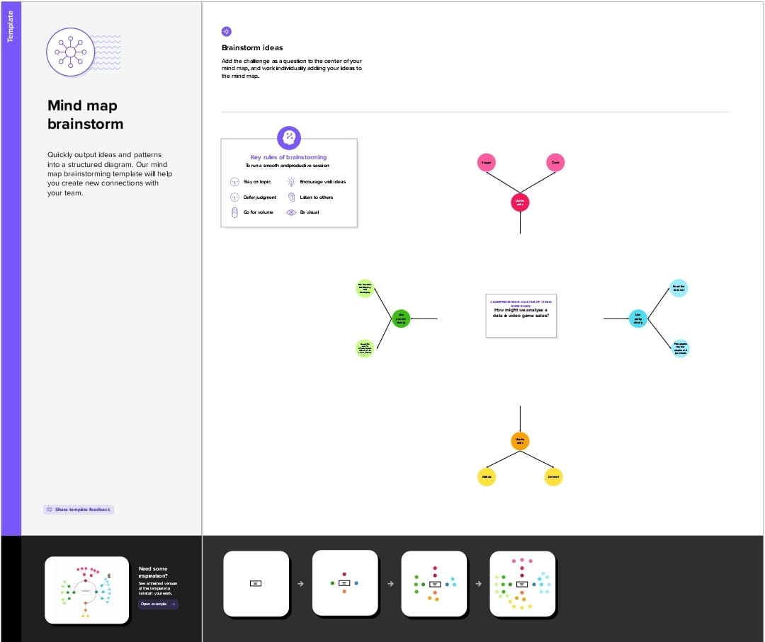

**3**  **RESULT**

**DASHBOARD**

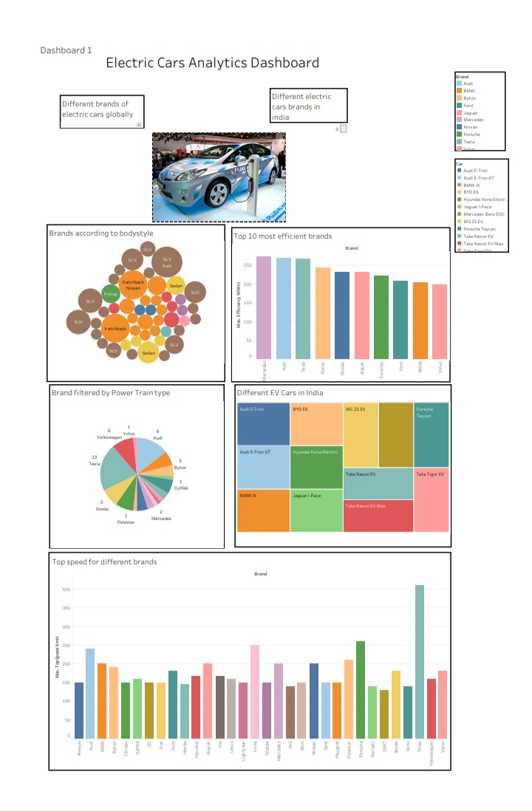

**STORY**

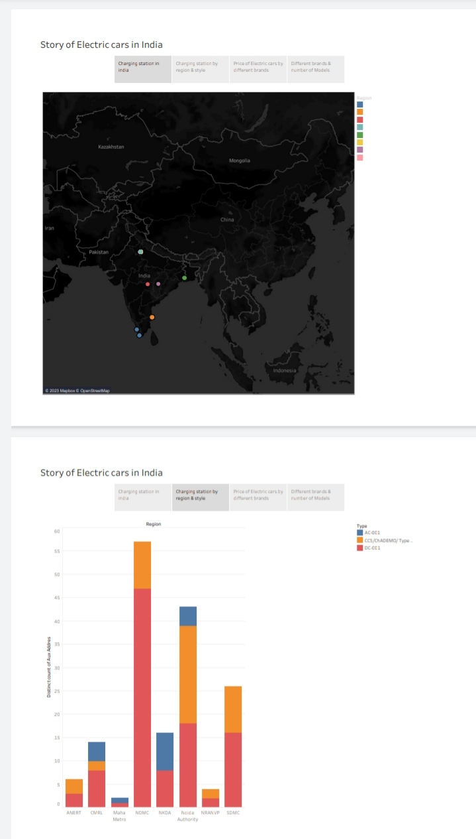

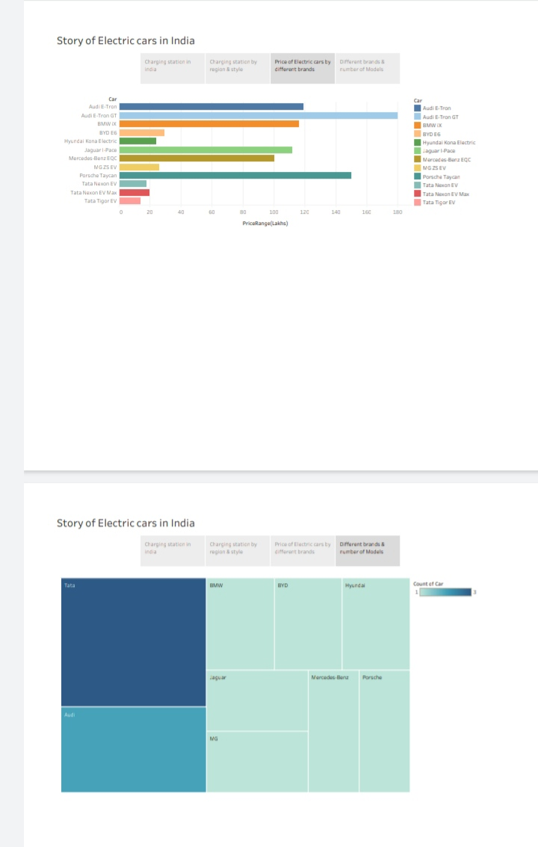Web integration image

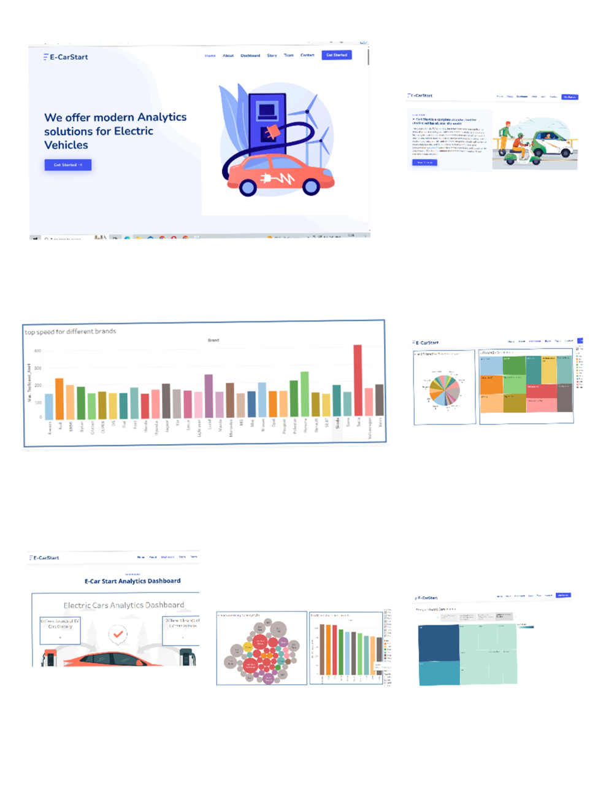

**4 ADVANTAGES & DISADVANTAGES**

List of advantages and disadvantages of the proposed solution

Advantages:

Cheaper and more easy to charge

One of the best advantage of using EV is best speed experience.

Disadvantages:

The unavailability of the required charging station in India.

1. **APPLICATION**

The Data Analysis of this project application is people selecting the best Electric Vehicle among various brands in markets across the globally and in India.

1. **CONCLUSION**

The conclusion of this project is easy to understand within EV brand is most efficient, which EV brand have top speed car etc.., and most important point is visualization tool of charge and range analysis.

1. **FUTURE SCOPE**

The EV charging station market is expected to grow 5 to 7 times in the next 5 years. The government wants India to be a 100% EV nation by the year 2030.